1. 下載憑證

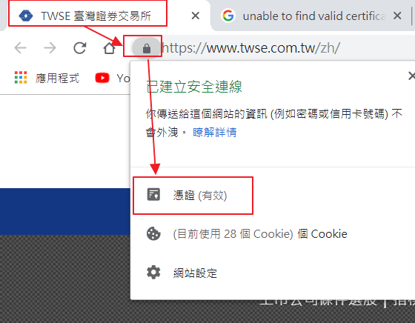

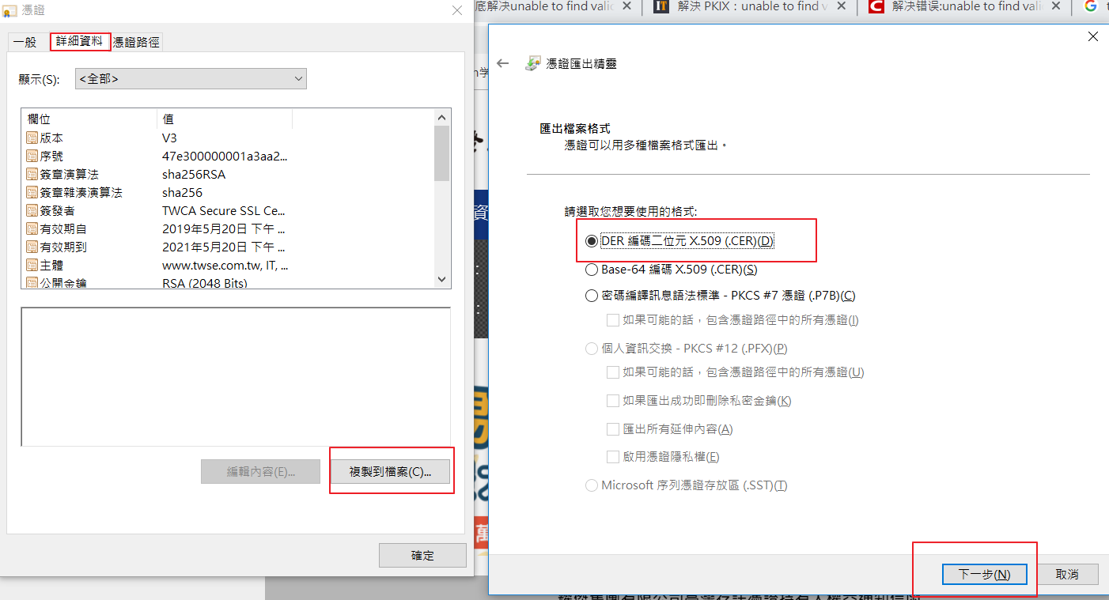

1. 將下載的憑證放到%JAVA_HOME%\jre\lib\security
2. Cmd cd /d %JAVA_HOME%\jre\lib\security
3. keytool -import -file ${憑證檔名} -keystore cacerts -alias server
4. 密碼 : changeit

